**Lab No. 04: Logical Instruction, Use of lo and hi Registers through, Multiplication and Division & Character Manipulation**

**Objectives:**

* Recognize and apply logical MIPS assembly language instructions.
* Acquire the ability to multiply and divide using the lo and hi registers.
* Use shift instructions to manipulate bits.
* Recognize and use masking techniques to change or isolate particular parts.
* To identify and flip particular bits in a register, use exclusive-or.

**Task 1: Division Multiplication**

1. Create a directory for this lab’s files and open SPIM with hex display in the register pane.
2. Write code to perform integer division using div and use mflo and mfhi to retrieve the quotient and remainder.
3. Modify the code to also calculate and display the product using the `mult` instruction.

**Code:**

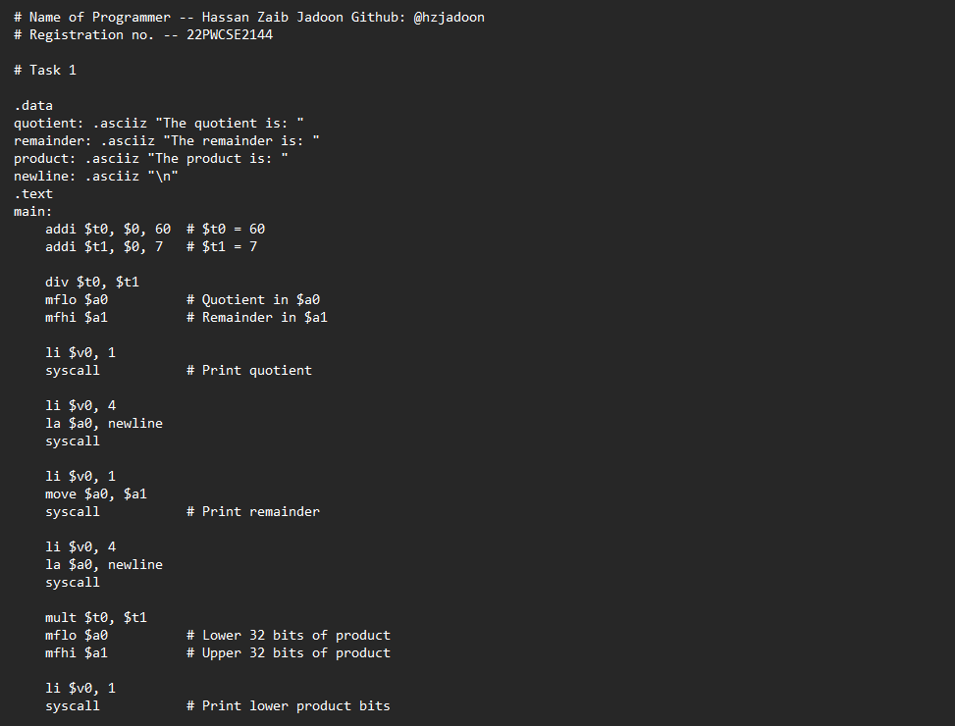

**Output:**

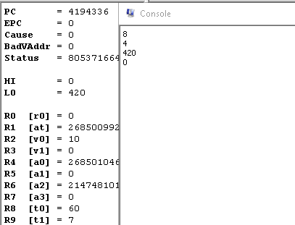

**Task 2: Bitwise Shifting**

1. Write code to shift a value to the left and right.
2. Experiment with different shift amounts and analyze the binary and hex representation.

**Code:**

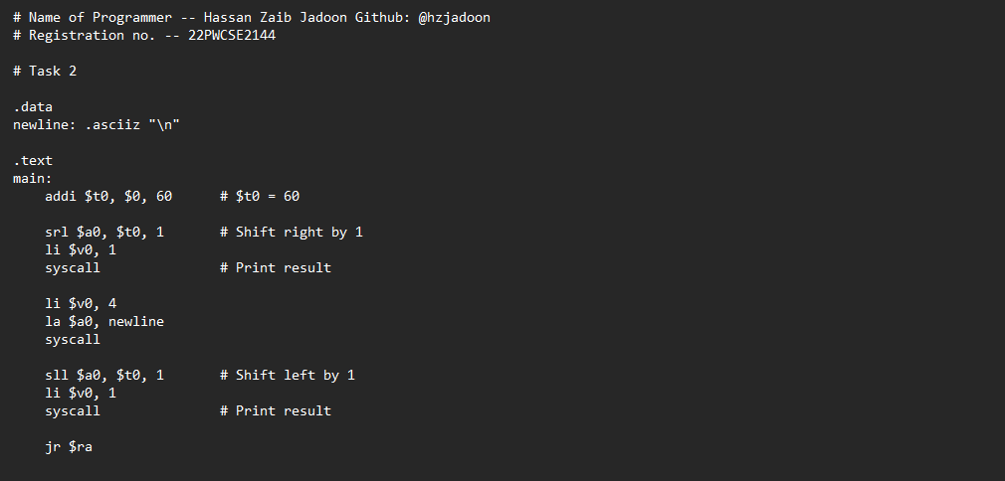

**Output:**

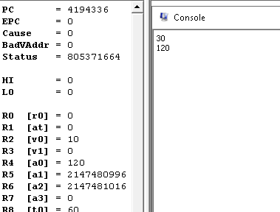

**Observations:**

* Right shifts correspond to division by powers of 2.
* Left shifts correspond to multiplication by powers of 2.

**Task 3: Integer Multiplication by Shifting**

1. Calculate 18 * x using shift instead of the mult instruction.

**Code:**

**Output:**

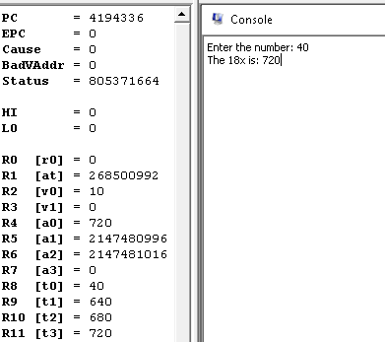

**Task 4: Isolating a Specific Bit**

1. Isolate bit #10 of an integer by using shifts and masking techniques.

**Code:**

**Output:**

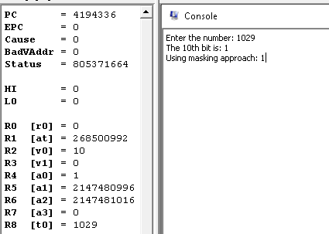

**Task 5: Clearing a Specific Bit**

1. Clear bit #10 in an integer using a mask and verify using `andi` and `ori`.

**Code:**

**Output:**

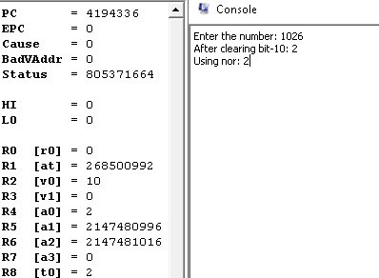

**Task 6: Flipping a Specific Bit (Lab4_6.s)**

1. Flip bit #10 using the xor instruction with an appropriate mask**.**

**Code:**

**Output:**

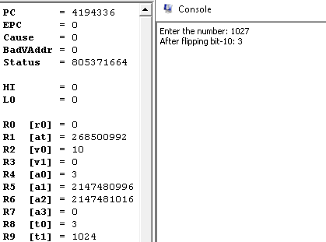

**Conclusion:**

In this lab, we learnt how to do arithmetic and logical operations using MIPS assembly instructions, specifically using the `lo` and `hi` registers for division and multiplication. We also looked at shifting and masking, which are effective ways to divide, multiply, and manipulate bits.